**Test Case** **0036**

**System:** VirtuCardsClient & VirtuCardsHost

**Description:** Test that the option to invite friends is implemented correctly

**Severity:** 3

**Instructions**

**Test 1**

1. Start VirtuCardClient application
2. Click the button labeled “Sign In”
3. Enter “gamer1@gmail.com” into the text input labeled “Enter email…”
4. Enter “CS30700” into the text input labeled “Enter password…”
5. Press the button labeled “Login”
6. A window should appear saying “Login Success”
7. Press the OK button that appears on that window
8. Start VirtuCardHost application
9. Click the button labeled “Sign In”
10. Enter “micro@soft.com” into the text input labeled “Enter email…”
11. Enter “Password!123” into the text input labeled “Enter password…”
12. The checkbox “Allow Host to Join” should be checked on the host
13. On the dropdown select test game as the gamemode
14. Press the Create Game Button
15. On the waiting screen on the host, click the invite friends button

**Expected Result:** A panel with a dropdown showing all the hosts friends should appear. When clicked gamer1, gamer2, and gamer3 should show up on the panel.

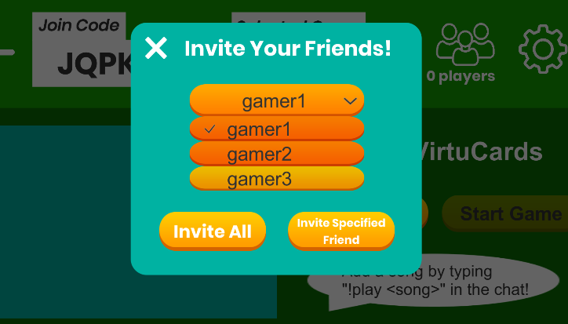

* This is what should be displayed when you click the invite friends panel

1. Now select gamer1 and click the invite specified friend button.

**Expected Result:** On the host, a confirmation screen should show up showing that gamer1 has been invited, and on gamer1’s screen they should have a panel that pops up showing the room information.

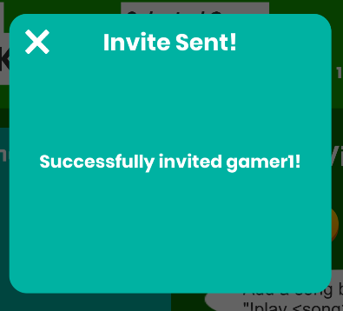

* This is what the panel on the host should look like, confirming that you invited gamer1 successfully.

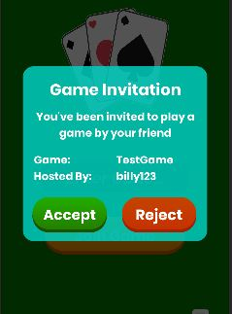

* This is what should be displayed on the client side when an invite is sent to the player

1. Now the client should accept that invitation

**Expected Result:** The client should be redirected to the waiting screen and then the host waiting room should display that player in the waiting room.

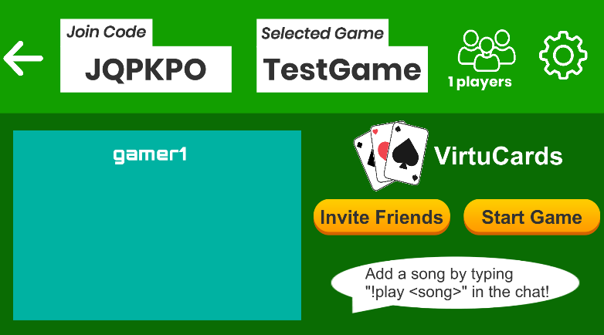

* Here is the waiting room after the client has accepted the invitation

**Test 2**

1. Start VirtuCardClient application
2. Click the button labeled “Sign In”
3. Enter “gamer1@gmail.com” into the text input labeled “Enter email…”
4. Enter “CS30700” into the text input labeled “Enter password…”
5. Press the button labeled “Login”
6. A window should appear saying “Login Success”
7. Press the OK button that appears on that window
8. Start VirtuCardHost application
9. Click the button labeled “Sign In”
10. Enter “micro@soft.com” into the text input labeled “Enter email…”
11. Enter “Password!123” into the text input labeled “Enter password…”
12. The checkbox “Allow Host to Join” should be checked on the host
13. On the dropdown select test game as the gamemode
14. Press the Create Game Button
15. On the waiting screen on the host, click the invite friends button

**Expected Result:** A panel with a dropdown showing all the hosts friends should appear. When clicked gamer1, gamer2, and gamer3 should show up on the panel.



* This is what should be displayed when you click the invite friends panel

1. Now select gamer1 and click the invite all button.

**Expected Result:** On the host, a confirmation screen should show up showing that all players have been invited, and on gamer1’s screen they should have a panel that pops up showing the room information. The behavior of the invite function should not be affected by other players who may or may not be online. (at this point offline)

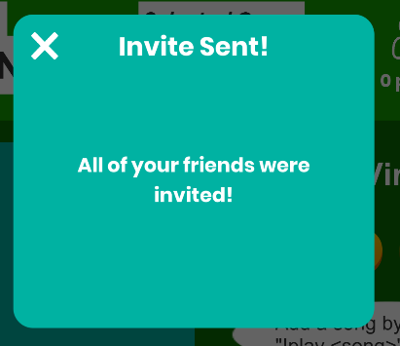

* This is what the panel on the host should look like, confirming that you invited all players successfully.



* This is what should be displayed on the client side when an invite is sent to the player

1. Now the client should accept that invitation

**Expected Result:** The client should be redirected to the waiting screen and then the host waiting room should display that player in the waiting room.



* Here is the waiting room after the client has accepted the invitation

**Test 3**

1. Start VirtuCardClient application
2. Click the button labeled “Sign In”
3. Enter “gamer1@gmail.com” into the text input labeled “Enter email…”
4. Enter “CS30700” into the text input labeled “Enter password…”
5. Press the button labeled “Login”
6. Start another VirtuCardClient Application
7. Click the button labeled “Sign In”
8. Enter “gamer2@gmail.com” into the text input labeled “Enter email…”
9. Enter “CS30700” into the text input labeled “Enter password…”
10. Press the button labeled “Login”
11. A window should appear saying “Login Success”
12. Press the OK button that appears on that window
13. Start VirtuCardHost application
14. Click the button labeled “Sign In”
15. Enter “micro@soft.com” into the text input labeled “Enter email…”
16. Enter “Password!123” into the text input labeled “Enter password…”
17. The checkbox “Allow Host to Join” should be checked on the host
18. On the dropdown select test game as the gamemode
19. Press the Create Game Button
20. On the waiting screen on the host, click the invite all friends button

**Expected Result:** A panel with a dropdown showing all the hosts friends should appear. When clicked gamer1, gamer2, and gamer3 should show up on the panel.



* This is what should be displayed when you click the invite friends panel

1. Now select gamer1 and click the invite all button.

**Expected Result:** On the host, a confirmation screen should show up showing that all players have been invited, and on gamer1’s screen they should have a panel that pops up showing the room information. This should also happen on gamer2’s screen. The behavior of the invite function should not be affected by other players who may or may not be online. (at this point gamer3 is offline)



* This is what the panel on the host should look like, confirming that you invited all players successfully.



* This is what should be displayed on the client side when an invite is sent to the player for both gamer1 and gamer2

1. Now gamer1 and gamer2 should now both accept the request

**Expected Result:** The client should be redirected to the waiting screen and then the host waiting room should display that players in the waiting room.

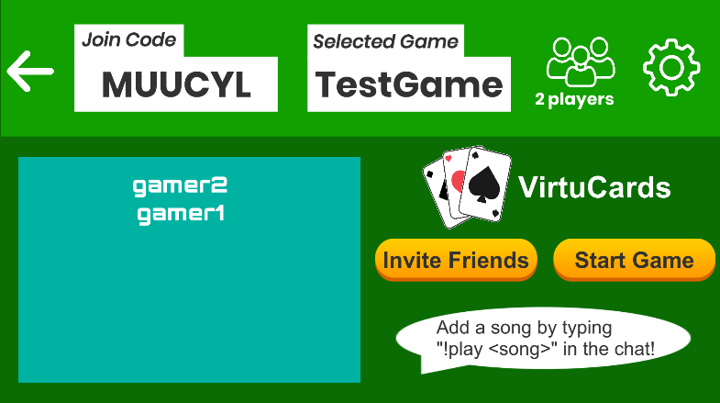

* Here is the waiting room after the clients have accepted the invitations

**Test 4**

1. Start VirtuCardClient application
2. Click the button labeled “Sign In”
3. Enter “gamer1@gmail.com” into the text input labeled “Enter email…”
4. Enter “CS30700” into the text input labeled “Enter password…”
5. Press the button labeled “Login”
6. Start another VirtuCardClient Application
7. Click the button labeled “Sign In”
8. Enter “gamer2@gmail.com” into the text input labeled “Enter email…”
9. Enter “CS30700” into the text input labeled “Enter password…”
10. Press the button labeled “Login”
11. A window should appear saying “Login Success”
12. Press the OK button that appears on that window
13. Start VirtuCardHost application
14. Click the button labeled “Sign In”
15. Enter “micro@soft.com” into the text input labeled “Enter email…”
16. Enter “Password!123” into the text input labeled “Enter password…”
17. The checkbox “Allow Host to Join” should be checked on the host
18. On the dropdown select test game as the gamemode
19. Press the Create Game Button
20. On the waiting screen on the host, click the invite all friends button

**Expected Result:** A panel with a dropdown showing all the hosts friends should appear. When clicked gamer1, gamer2, and gamer3 should show up on the panel.



* This is what should be displayed when you click the invite friends panel

1. Now select gamer2 and click the “invite specified friend” button.

**Expected Result:** On the host, a confirmation screen should show up showing gamer2 has been invited. Now that two players are online, only gamer2 should receive the invite. If gamer1 receives an invite, there is a problem.

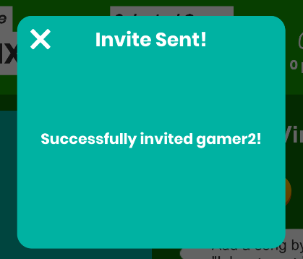

* This is what the panel on the host should look like, confirming that you invited gamer2 successfully



* This is what should be displayed on the client side when an invite is sent to the player for just gamer2 even though gamer1 is online

1. Now gamer2 should accept that request

**Expected Result:** The client should be redirected to the waiting screen and then the host waiting room should display that players in the waiting room.

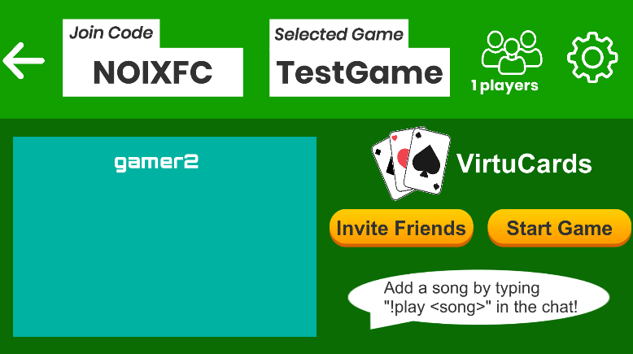

* Here is the waiting room after gamer2 has accepted the invitation